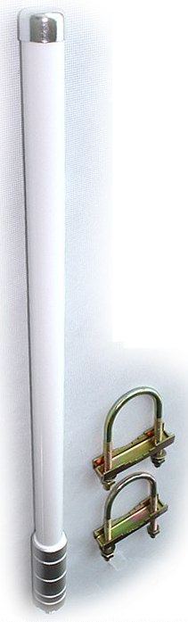
Marine Antenna
(ANT-OM8)

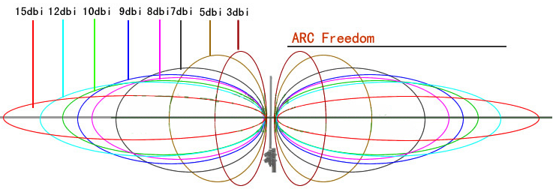
The Marine antenna is ideal for applications with tri-band repeaters or for use where coverage on multiple networks is required. Since this antenna is omni-directional, it does not need to be oriented towards a particular base station. The aerial will pick up signal from all directions and should be mounted as high as possible for best results. This antenna is particularily popular for marine applications in boats and yachts as well as mobile vehicle applicaitons in caravans and trucks.

Specification
Frequency Range | 800~960 MHz/1710~2500 MHz
Gain | 7dB/8dB
Polarization | Vertical
Half Power Beam-width | H:360° V: 45°/20°
Impedance | 50 ohms
VSWR | ≤2.0
Maximum Input Power | 200 Watts
Connector Type | N-Female
Weight | 0.6 kg
Dimension | Φ25×580mm
Temperature Range | -55~70°C
Humidity,% | 95%
Mounting | Pole Mounting
Grounding | DC grounded

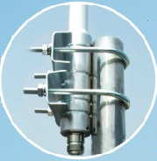
Installation Requirement

- Mount as high as possible to take advantage of line-of-sight.
- Mount away from large metal objects
- Mount away from other antennas
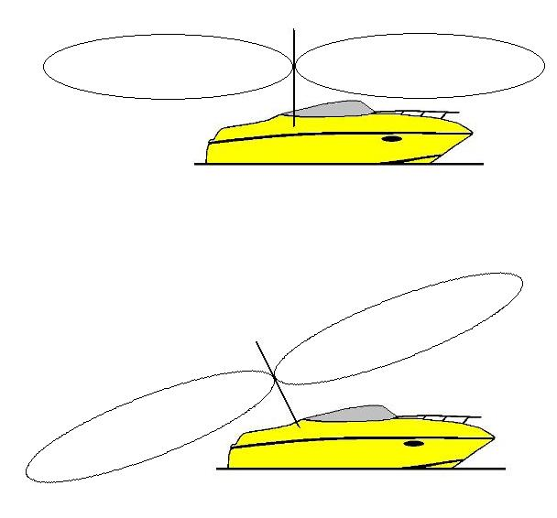
- Mount at least 1 meter away from phone user

